Pokhara University

Level: Bachelor | Semester – Spring | Year : 2008
Programme: BE |  | Full Marks: 100
Course: Engineering Mathematics IV |  | Time : 3hrs.

Candidates are required to give their answers in their own words as far as practicable.
The figures in the margin indicate full marks.

Attempt all the questions.

 | - Define harmonic function. Prove that u = y³ – 3x²y is a harmonic function. Determine its harmonic conjugate v of function f(z).  - State and prove Cauchy integral formula. Use it to integrate 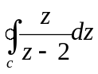 where c: ׀z׀ = 2 counterclockwise. | 8  7
 | - Define zeros and pole of a function f(z). Find the Residues of f(z) = 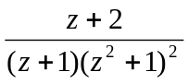.  OR  Find Laurent series of the function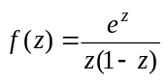, which converges to 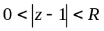.  - Define Z transform. State and prove first shifting theorem of Z transform. Using it evaluate Z transform of 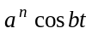and 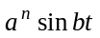. | 7  7  8
 | - State and prove initial and final value theorem on Z transform. Evaluate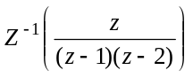.  - Solve the difference equation: 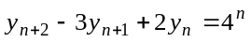, where 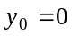and 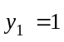. | 7  8
 | - Derive one dimensional heat equation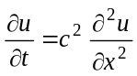 with required assumption.  - Find u(x, t) of the tightly stretched string of length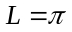, when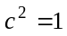, zero initial velocity and initial deflection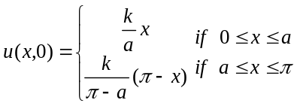. | 7  8
 | - Derive two dimensional heat equation and wave equation with required assumptions.  OR  Solve two dimensional wave equation 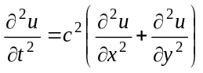, in circular membrane.  - Maximize : z = 90x₁ + 50x₂  Subject to x₁ + 3x₂ ≤ 18  x₁ + x₂ ≤ 10  3x₁ + x₂ ≤ 24 | 8  8  7
 | - Find the fourier Integral of  f(x) = 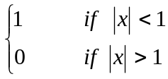  - Find the Fourier Transform of  f(x) = 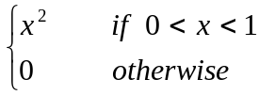  OR  Let f(x) be continuous and absolutely integrable on x – axis, f(x) be piecewise continuous on each finite interval and f(x) → 0 as x → ∞, then F_{c} [f(x)] = wF_{s} [f(x)] - 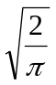f(0) and F_{s} [f' (x)] = - wF_{c} [f(x)] | 8  7  7
 | - Write down Laplacian in polar and cylindrical coordinate systems.  - Find tangent vector on the curve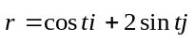, at 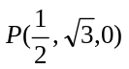  - Find the poles of the function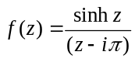.  - Find real part of e^{z}.  - Solve the partial differential equation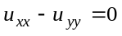, by using separation of variables methods. | 5×2

